**Automated Speck Assay Manual**

Welcome! This manual will provide you with a guide on how to use our script for analysing your own speck assays, along with how to customise the settings to best suit your data and assay setup, even if you don’t know much (or anything) about R.

Setting up the program on your own machine

1. First off, you’ll need to have R and RStudio installed
2. You’ll notice there are multiple files included in our repository, most of the time you won’t need to worry about these, but for the first time you’ll need to open “Packages.R” which should look like this: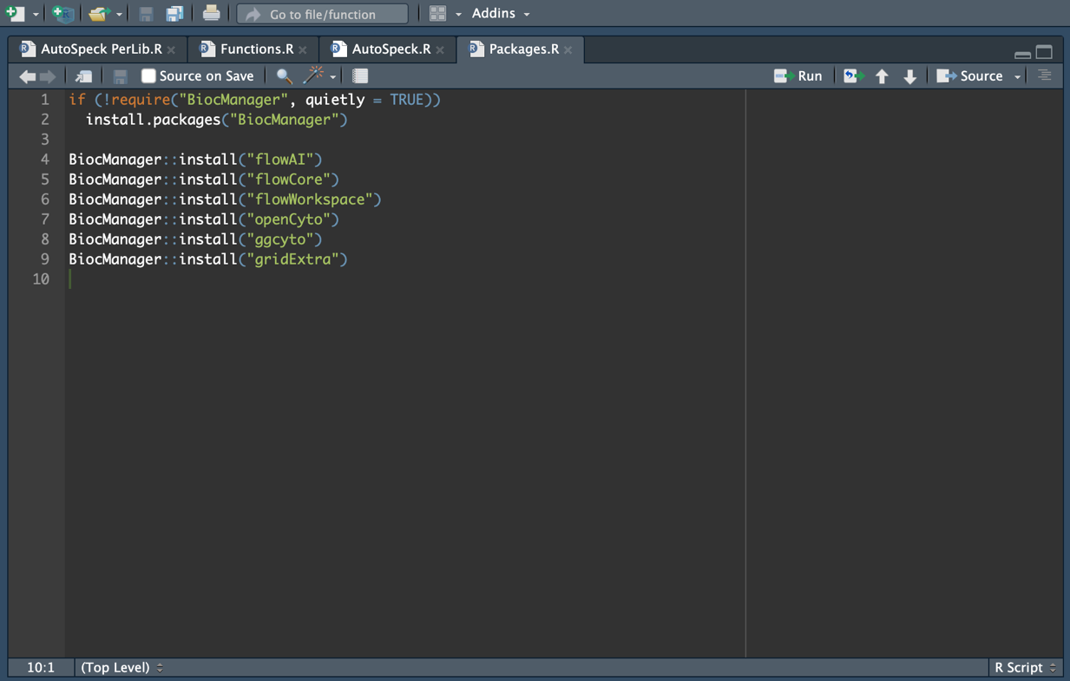
3. Click ‘Source’ (highlighted in the top right) to run the code, which will install the packages required to run the program
4. Once this is done, you can close this file

Setting your parameters

1. Once you have all the required packages, we can then move on to opening the main program and setting your parameters
2. First, you should load your FCS files so that they may be accessible by the program. Take your files and move them to the “Data” folder
3. Open “AutoSpeck.R”
4. The first parameter you will need to set is “Path”, which is the location of your data. Here’s an example below: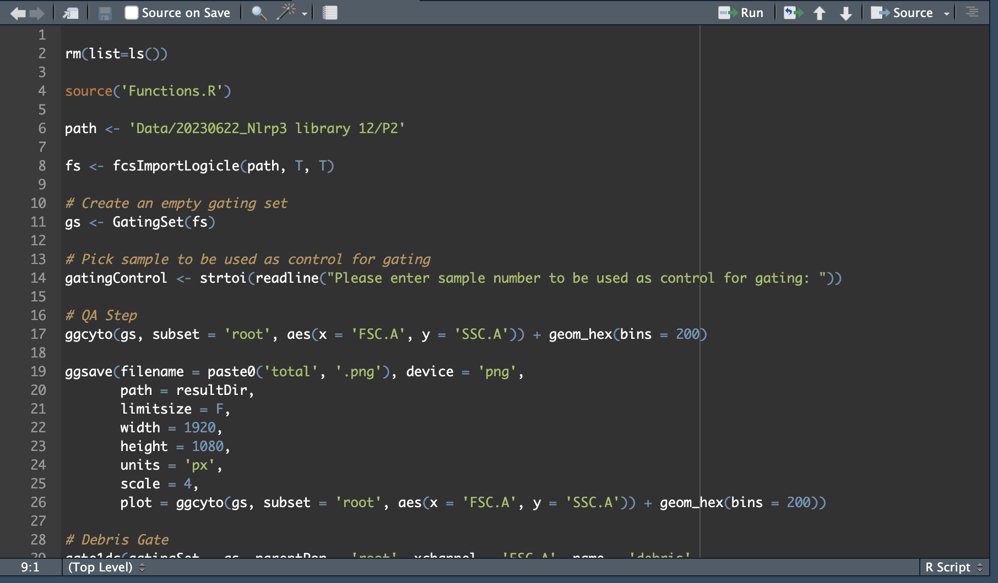
5. Next, we can move on to setting the required gates. You can see the channels available by running the command “channelInfo(‘**Path to your data**’)” (Channel names may be slightly altered during import of the data. If you’re running this for the first time it is good to check)
6. Our first gates are for filtering out debris and isolating single cells: 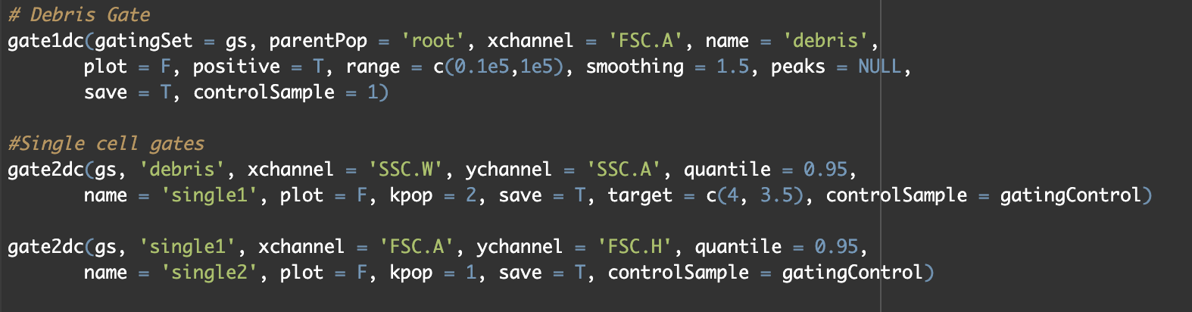
7. The Debris gate is one-dimensional, meaning it gates based on a histogram of a single channel, in this case ‘FSC.A’. If you wish to use a different channel, simply change the name under the **xchannel** parameter (A detailed breakdown of each function will be included at the end of this manual if you wish to further tailor your output)
8. The next gates are for the purpose of sorting single cells. In much the same way, you can change these channels as required, however this will likely not be the case as FSC and SSC channels should always be present in your files
9. Next up are the speck gates. This is done in the following step:A screen shot of a computer program

   Description automatically generated
10. Like before, here you can input the channel you wish to perform the gating on. We have found that speck positive cells can be gated using a 1d gate on the width parameter of your speck marker. In our setup above, the cells are ASC-BFP, so we are using the ‘V450.50.W’ channel. It is important to make sure that the settings are the same for both the functions above, as they should generate the same gate. The only difference between them is that one gates on the positive population and the other on the negatives.
11. Finally, we can move on to how the data is analysed. Here we have a function for exporting the single cell fluorescence values for NLRP3:
12. The only value we need to worry about here is the final one, in the above example set to “B530.30.A”. This is the channel we wish to export single cell values for, which should be a readout of NLRP3 expression. As previously, change this to whichever channel you are using depending on your fluorophore.

Running the Program

1. You should now be good to go! Click “Source” in the top right to run the program. You will be prompted on which channels should be transformed from linear to logistic: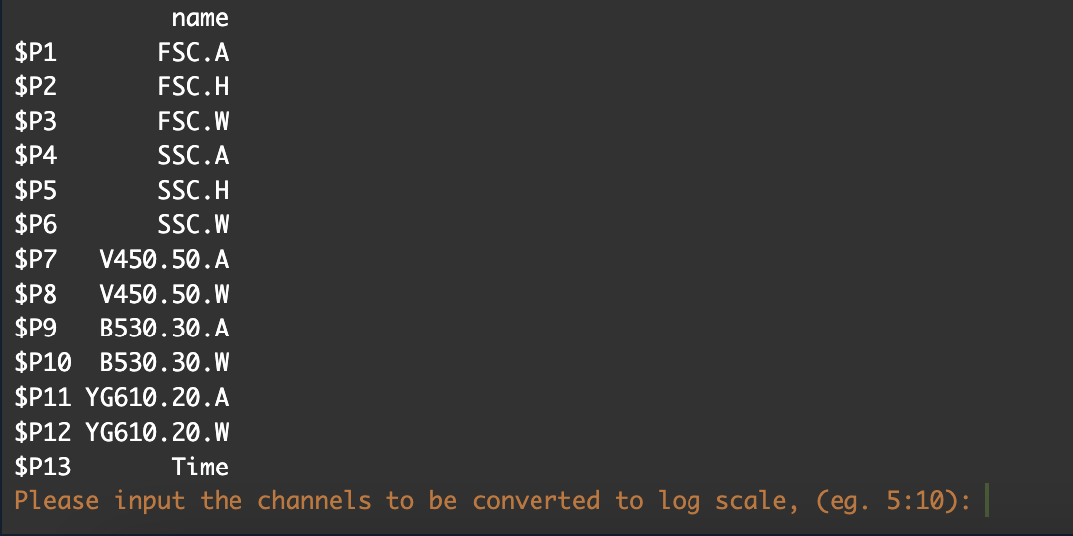
2. This currently accepts an input as a range of values (eg. 5:7 would be values 5, 6, 7), which represent the various fluorescence channels present in the file. Select a range that includes everything other than time and FSC. In the example above this would be 4:12.
3. You will then be prompted to input the sample number corresponding to your control sample, which should be your WT. We advise using the first sample as a control for convenience. Keep in mind that samples are ordered by name, and cytometers will often number samples based on the order they are acquired, meaning the same number could correspond to different well positions depending on if the plate is read vertically or horizontally. You can check this by sorting your FCS files by name.
4. Once the program has completed, you should be able to see a new folder inside the ‘Results’ folder, which will contain graphical representations of all the gating applied, a summary graph of relative ec50 values, the fitted curves used to generate ec50 values, and an excel sheet of all the output data.